

**Lab Report**

**Group-1**

**Course Code : CSE-418**

**Course Title : Web Engineering Lab**

***Submitted To***

**Md. Mahfujur Rahman**

**Department Of CSE**

**Daffodil International University**

***Submitted By***

1. **Mst.Sadia Sultana - 173-15-1662**
2. **Umma Habiba - 173-15-1635**
3. **Md.Imam Ahasan - 173-15-1686**
4. **Shoyeb Nazi - 173-15-1699**
5. **Md.Afzal Hossen - 173-15-1700**

**Date of Submission**

**16/12/2020**

***Report No – 01* :** Write a PHP program to insert name, id, age, and user name and password information entered by the user into a table created using MySQL and to display the current contents of this table.

* **Input :**

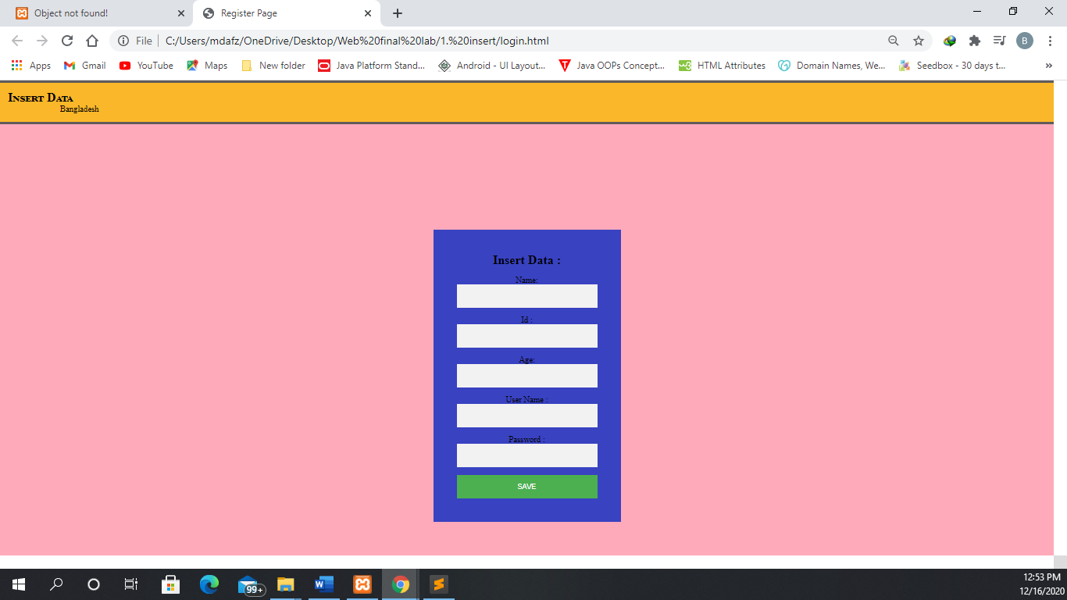

* **Output :**

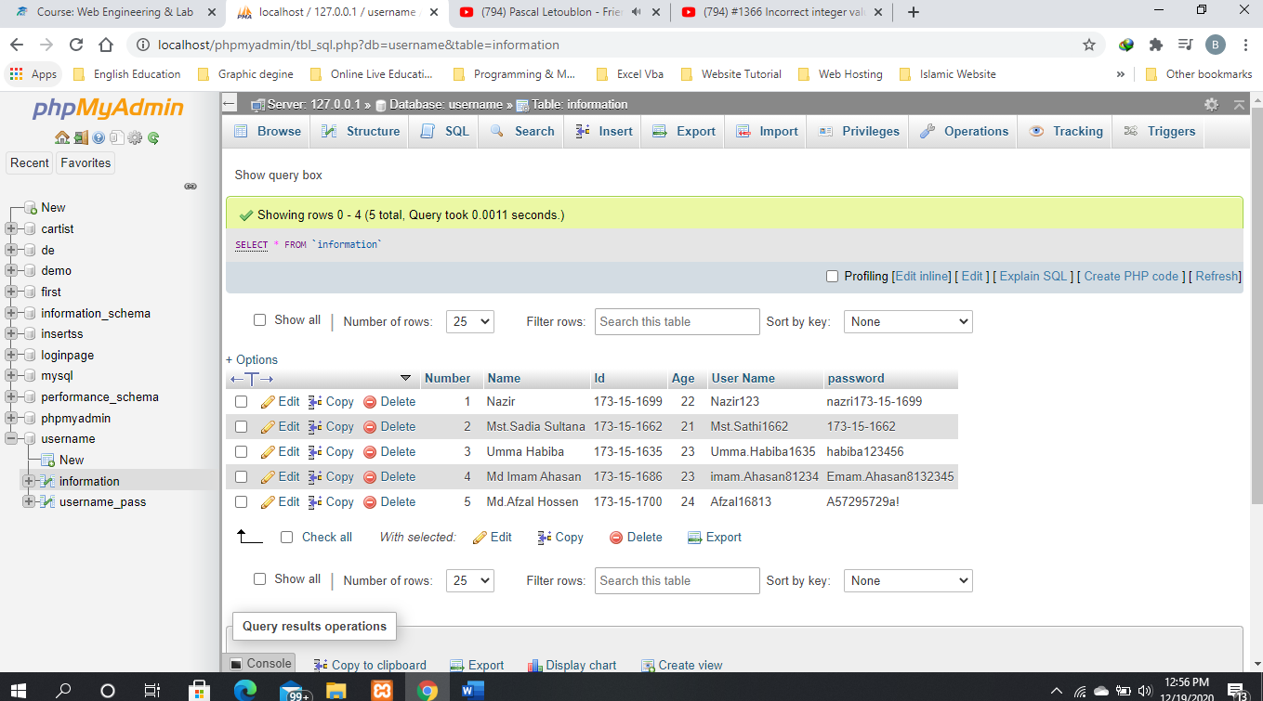

**Report No – 02 :** Write a PHP program to log in the system using session.

* **Input :**

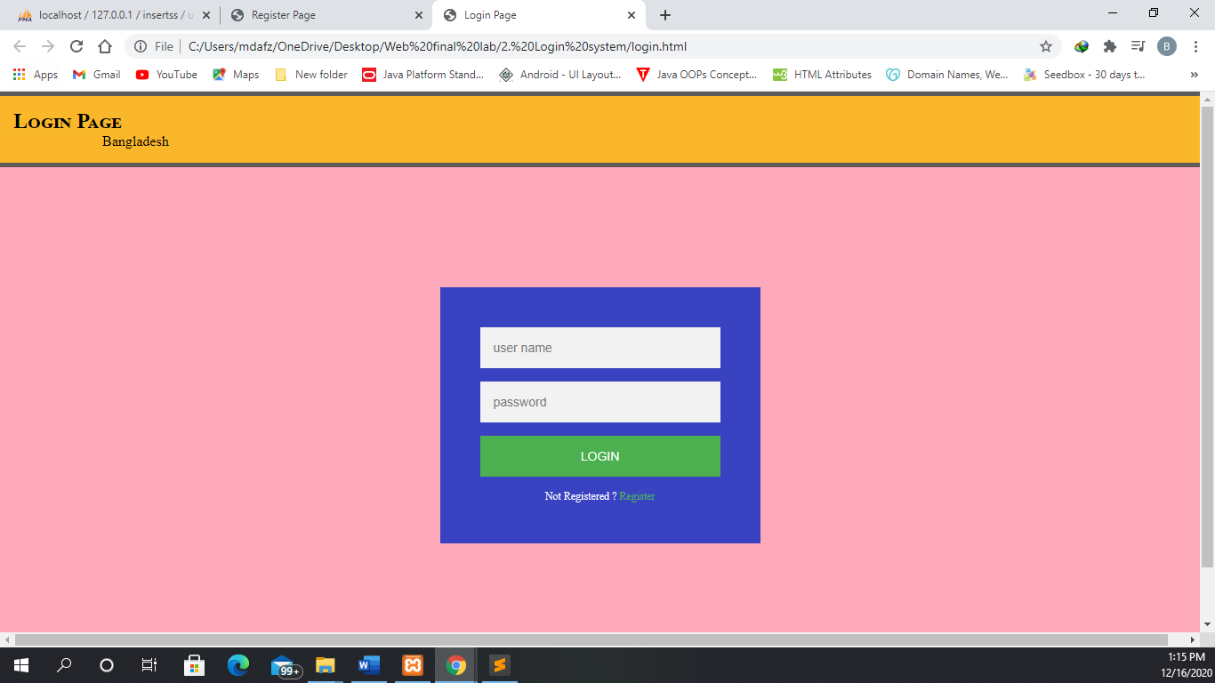

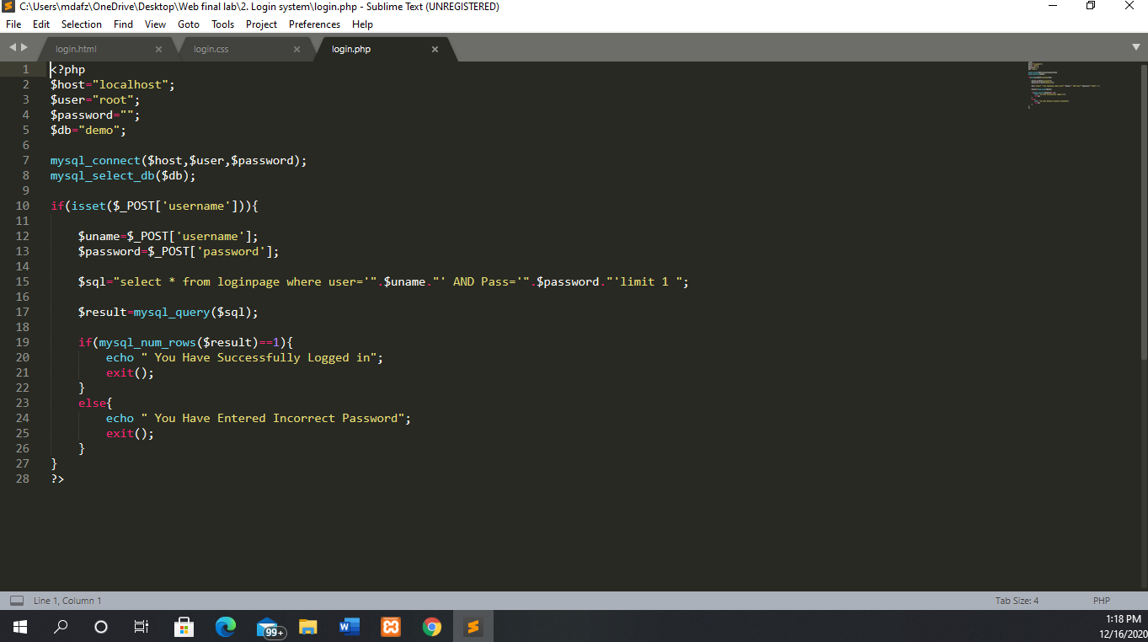

* **Output** :

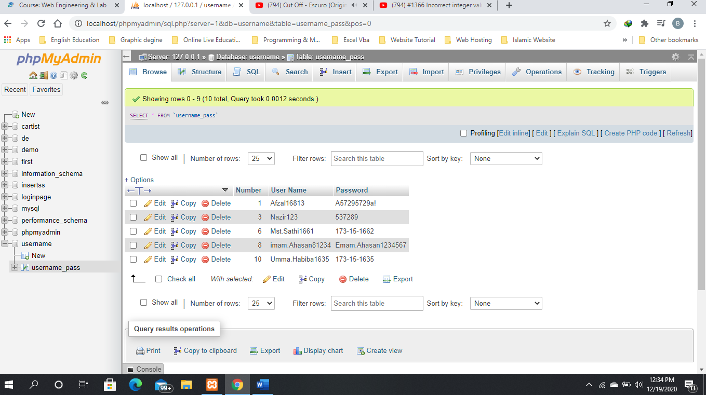

**Report No – 03 : Create Home page for a college for showing some important information such as Home,Abojut,Teacher Info, Notice board etc. Using HTML and CSS (Use Bootstrap).**

* **Input and Output :**

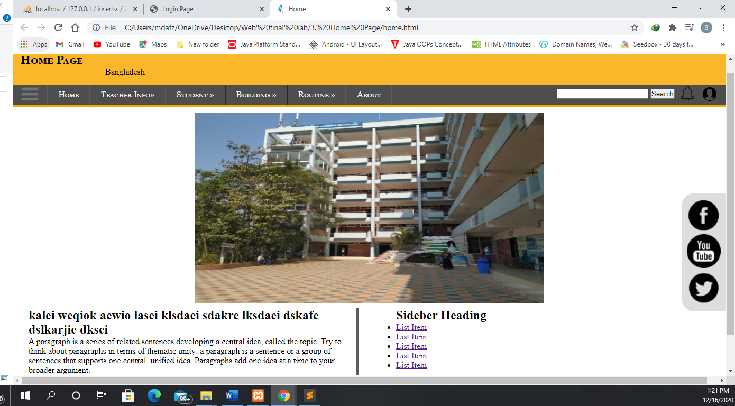

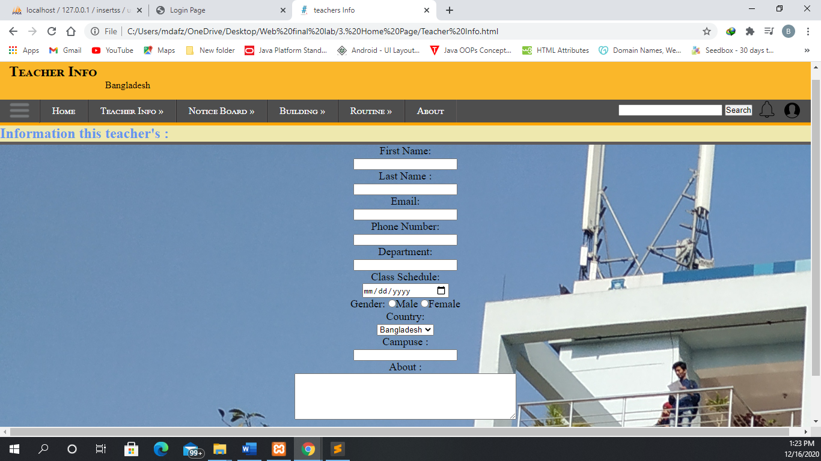

**Report No – 04 : Write a PHP program to see user registration info from database and delete a user individually.**

* **Input :**



* **Output :**

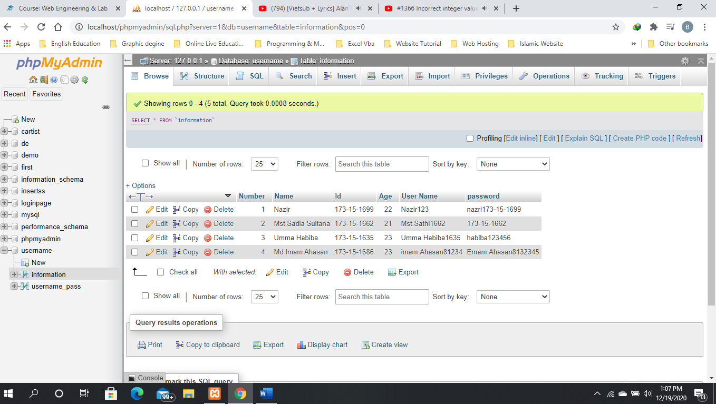

**Report No – 05 : Write a PHP program to see user registration info from database and edit a user individually.**

* **Input :**

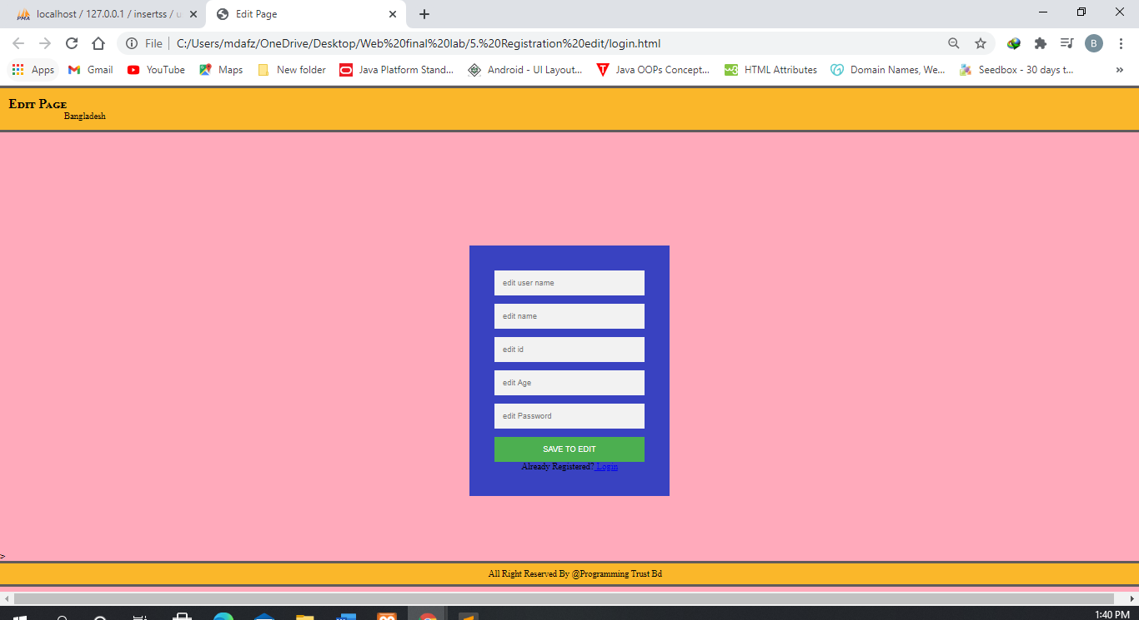

**Report No – 06 :** **Write a PHP program for SIGININ and SIGNUP using session and after Log into the system he/she will see all user registration information.**

* **Input :**

**Repot No – 07 : Write a PHP script to generate unique random numbers within a range.**

Sample Range :(11.20)

Sample Output : 17 16 13 20 14 19 18 15 11 12

* **Input Code :**

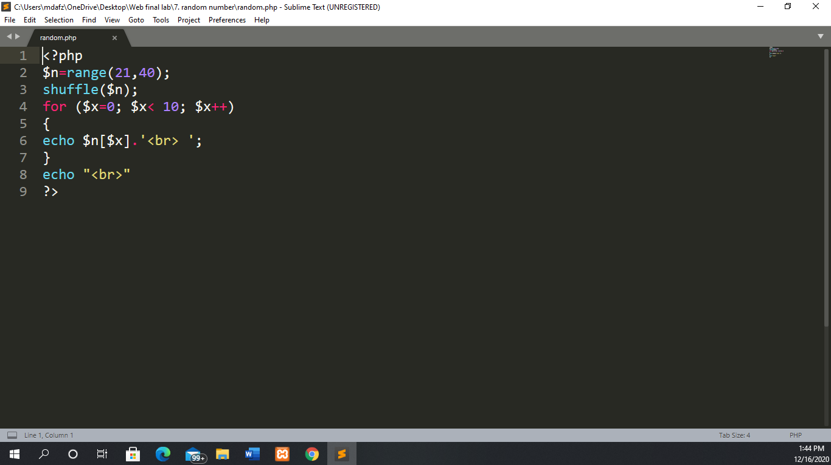

* **Output :**

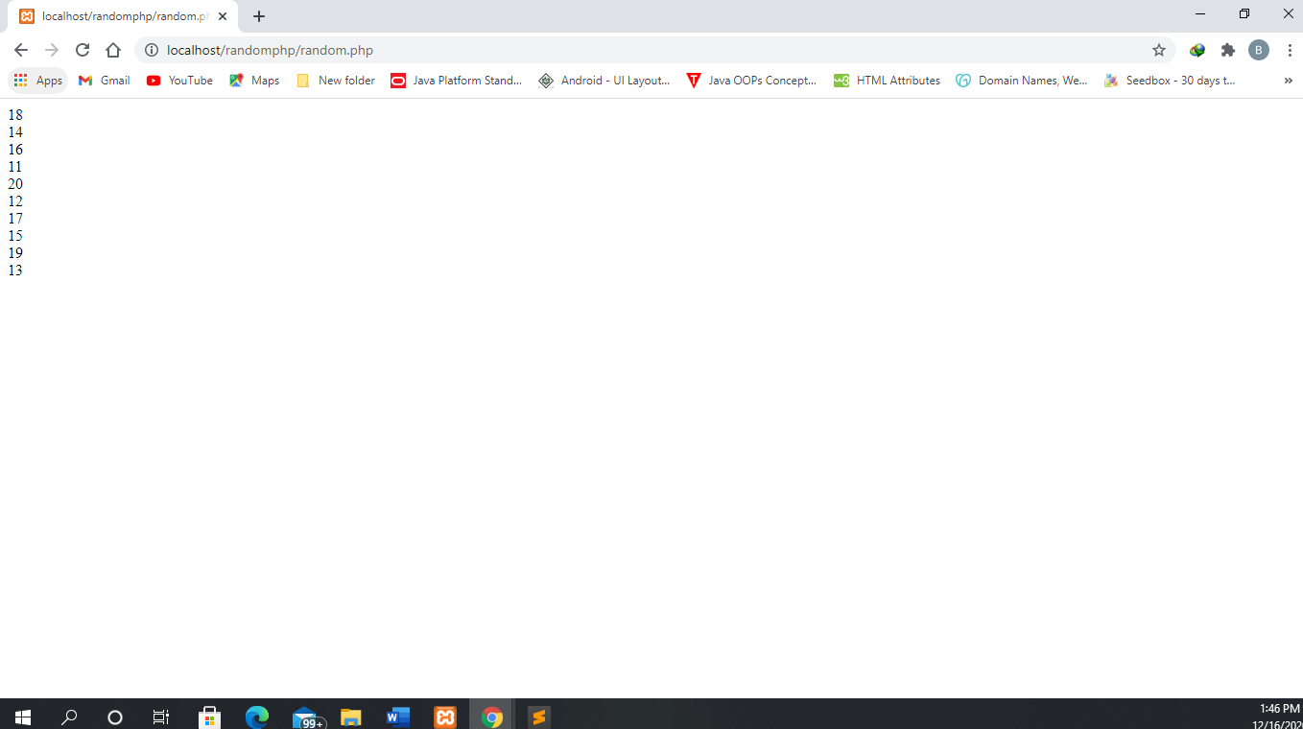

**Report No – 08 :**

* **Input Code :**

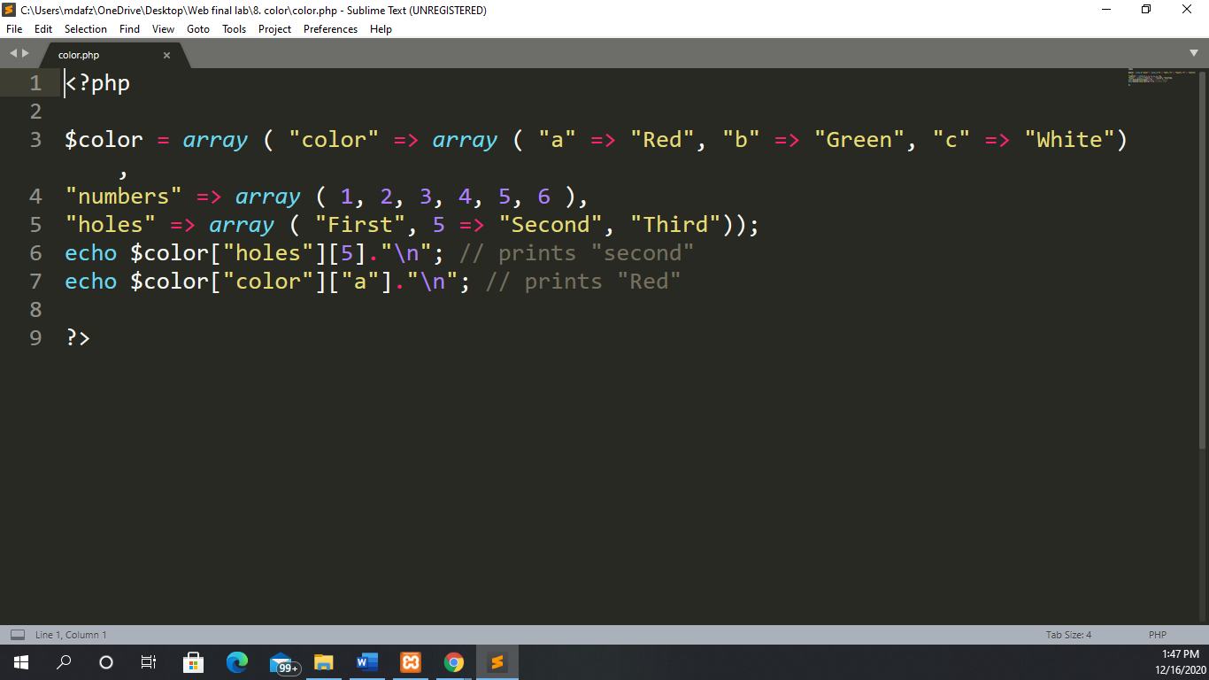

* **Output :**



**Report No – 09:**

* **Input Code :**

**Report No – 10 :**

* **Input Code :**

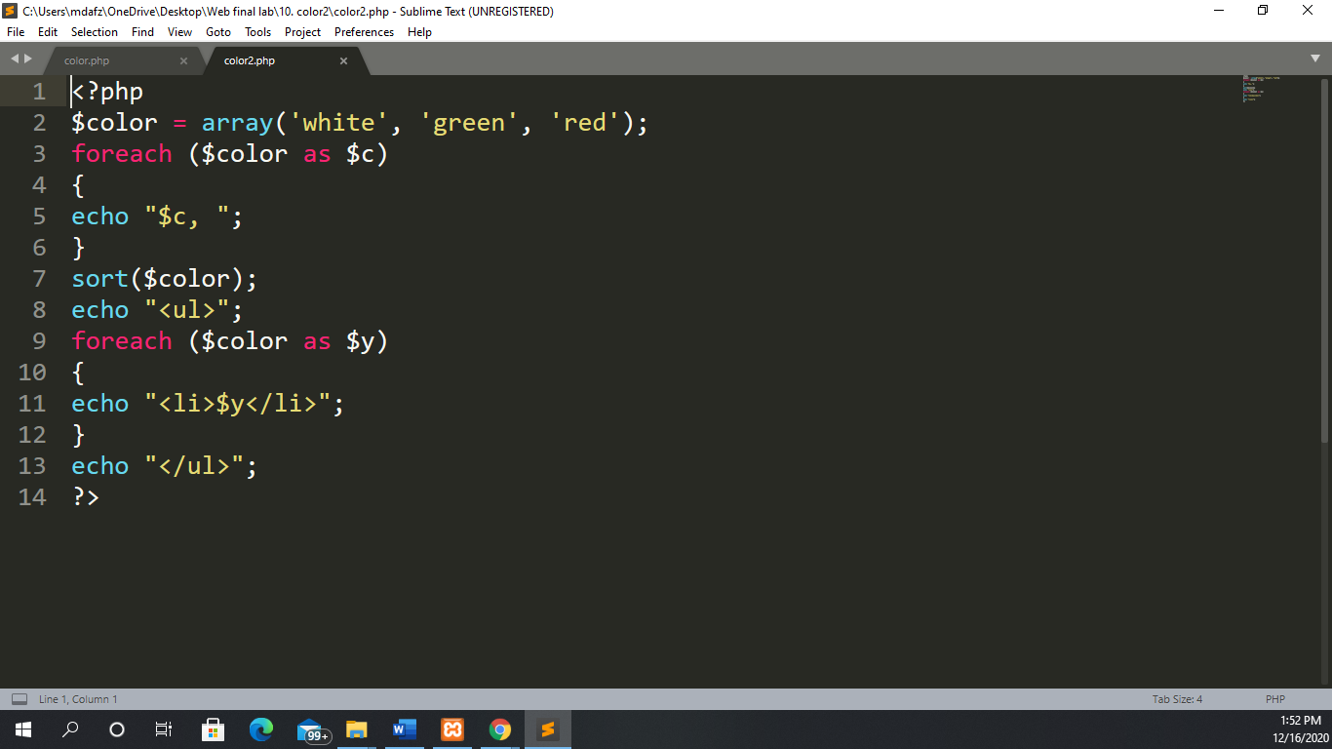

* **Output :**



**Report No – 11 :** Create registration form using HTML and CSS and save to the database.

* **Input :**

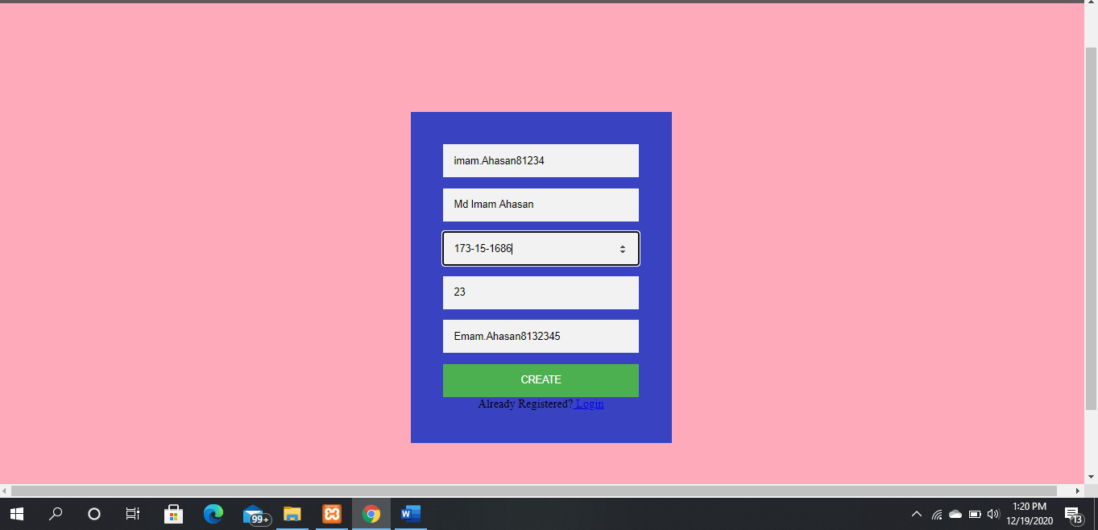

* **Output :**

